


Walsall Scouts

JOTA-JOTI 2026
  - One District. One Weekend. The Whole World.

Event Details
The World is Calling: Are You Ready?

Jamboree on the Air & Jamboree on the Internet (JOTA-JOTI) is the world’s largest digital Scouting event. Taking place online and over the airways, it connects millions of Young People and Adult Volunteers across 174 countries.

In 2026, Walsall District Scouts is bringing this global phenomenon to Beaudesert Outdoor Activity Centre for an unforgettable weekend of high-tech adventure.

One District. One Weekend. The Whole World.


Walsall Scouts
JOTA-JOTI 2026

  - Location and Dates
The event will be hosted at Beaudesert Outdoor Activity Centre, Cannock Chase between October 16th and 18th, 2026. The event runs 24 hours on these three days across the world to allow for different time zones. We will wait to confirm exact times and programmes closer to the time however, we hope that we can run for 24 hours from the Saturday morning and through the night.

  - Costs
Saturday Day Visitors (Beavers and Cubs): £20.00
Weekend Camping (Scouts, Explorers, Network): £40.00
Groups are to provide their own catering.

  - Participants
We are inviting the following sections to join the global conversation:
Saturday Day Visitors:
Beavers
Cubs
Full Weekend (Camping Option):
Scouts
Explorers
Network
As you can see, Beavers and Cubs will be day visitors. They will be allocated slots across the weekend closer to the time.
Each Group is required to be in ratio during the weekend as District Volunteers will not count – they will be supervising and running activities.

  - What’s Happening?
We are transforming Beaudesert into a global communications hub!
One District. One Weekend. The Whole World.

Why Your Group Needs to be There
The World is Calling: Are You Ready?

Jamboree on the Air & Jamboree on the Internet (JOTA-JOTI) is the world’s largest digital Scouting event. Taking place online and over the airways, it connects millions of Young People and Adult Volunteers across 174 countries.

In 2026, Walsall District Scouts is bringing this global phenomenon to Beaudesert Outdoor Activity Centre for an unforgettable weekend of high-tech adventure.

One District. One Weekend. The Whole World.

Walsall Scouts
JOTA-JOTI 2026

  - This isn’t just a camp; it’s a getaway to the world!
Your Young People and Adult Volunteers will develop digital citizen skills, build confidence speaking to strangers in a safe environment, and realise that they are part of a movement over 60 million members strong. It’s the easiest way to tick off International, Digital, and Communication badge requirements in one weekend!

  - Provisional Activities
Radio Communications:
Use amateur radio to speak with Scouts in distant lands.
Global Chatrooms:
Secure, moderated text-based chat with international peers.
Live Video Calls:
Face-to-face sessions with Groups from different continents.
Workshops & Challenges:
Informational sessions around staying safe online, and media relations. Hands-on STEM and Scouting activities, and challenges.

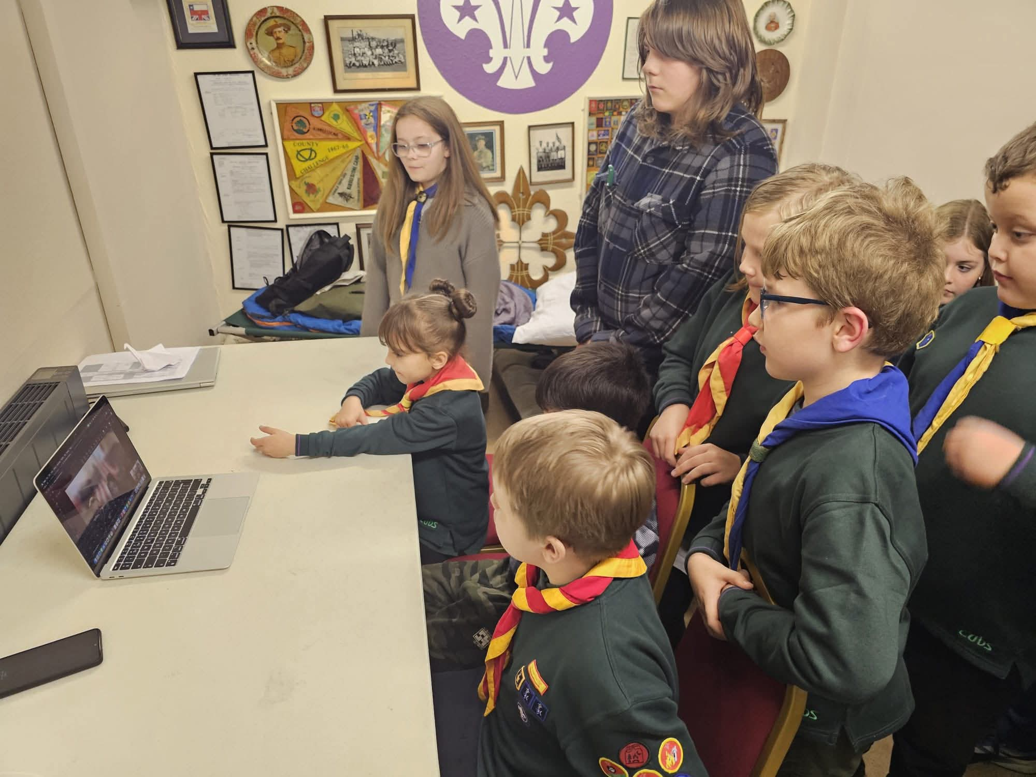

Sign Up to JOTA-JOTI
The World is Calling: Are You Ready?

Jamboree on the Air & Jamboree on the Internet (JOTA-JOTI) is the world’s largest digital Scouting event. Taking place online and over the airways, it connects millions of Young People and Adult Volunteers across 174 countries.

In 2026, Walsall District Scouts is bringing this global phenomenon to Beaudesert Outdoor Activity Centre for an unforgettable weekend of high-tech adventure.

One District. One Weekend. The Whole World.

Walsall Scouts
JOTA-JOTI 2026

  - How can your Group/Unit get involved?
Space at Beaudesert is limited and demand will be high.
Sign up on the Walsall Scouts website to secure your places!

Further enquiries?
Please contact: spencer.watson@walsallscouts.org.uk

